16-bit (not) RISC CPU

# Ammon Dodson

# Jake McKenzie

***Introduction:***

**Any computation can be split into sub-computations. Those sub-computations may be split even further. We call any computation that cannot be split any further: an instruction** (Mutlu 2015)**. Processing of instructions consists of components that transform data signals and components that determine what those transformations should be. This is done by establishing a *data path* and *control unit*** (Thimmannagari 2005, 5-6)***.* In this laboratory assignment we will create a processor which will allow any given *programmer* the ability to execute a set of instructions. This will be done by implementing the instruction set given to us in the design specifications and implementing components correctly to create a processor that will produce the desired output of the programmer. The processor made for this assignment, while being reduced, does not strictly follow all the RISC conventions as it does not have any pipelining of any kind.**

Experimental Design:

For this lab RTL code was first developed to match the design specifications. Processing the instruction is handled by a state machine where the current state is the programmer-visible state and next-state is the instruction execution specification (Wang 2017, 105-111). Many issues arose in the design and test of this RTL circuit, especially in the ALU and control unit which will be talked about further on in the laboratory assignment. First the data path then the control unit were designed as these were agreed upon to be the most important modules for our project. An ALU had already been designed for a passion solo project so we adapted it to fit the needs of this assignment. If we look at the simplest von Neumann model in figure 1, we see that the control unit, ALU, and datapath (included in the ALU and path between memory and CPU here) play the central role central role in the CPU. We did not make a strictly von Neumann model CPU because our data memory is separate from the instruction memory, which is some criteria von Neumann defined originally. This was because all computers at this time had no modular structure to them and were purpose built.

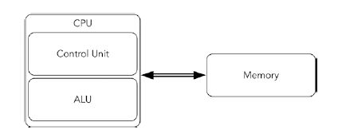

Figure 1: Simple von Neumann architecture (not exactly what we made here) (Zhirkov 2017, 4)

The ALU was previously developed with an add, subtract, and, or, xor, shift left, shift right, roll left, roll right but only the operations asked of us were used. Unused operations were not included. The adder module was built separately to ensure correct behavior for signed and unsigned overflow and underflow checking. Heavy use of explicit casting was needed in the testbench to ensure that our values were being treated exactly the way we wanted them to. Signed overflow was one of the more difficult parts of our testing for this assignment. After we completed this testbench we ensured that the ALU was working correctly. Conditional flags for correctness are often used in many processors, ARM based processors have a negative, zero, carry, overflow and saturation flag built into each instruction (Upton, et al. 2016, 134). While we made an overflow flag for this processor, the UART receiver we made previously had a saturating counter, which is often used in digital signal processing.

The control unit was developed in the form of a lookup table. The machine word opcode is used as an index into that table, and the different control signals are sent to their respective destinations. Restricting operands, as we did here, to registers simplifies the control unit (Dandamudi 2005, 43). Many iterations of the control unit happened. At first, we were incrementing PC counter incorrectly, by doing so both in the fetch and decode state. After fixing this we ran into an assortment of timing issues. The control unit’s job is to ensure that the rest of the processor is performing the correct instructions. The data path needs control signals which are driven by the control unit. To get the timing correct and to remove latching warnings, we had to make multiple always, always_ff and always_comb blocks to split up latching assignments from combinational assignments to reduce warnings.

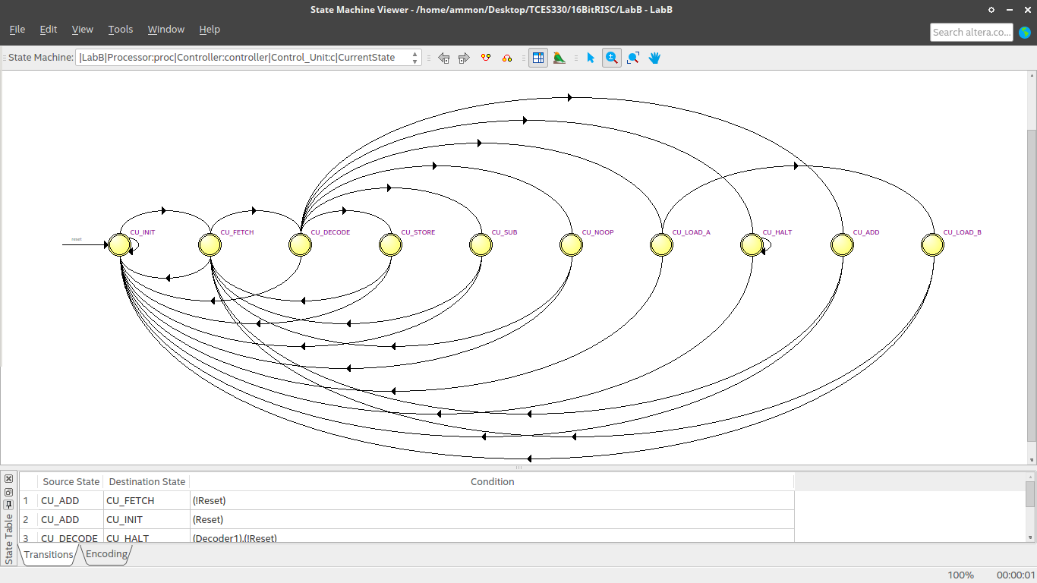

Figure 2: The finite state machine for the Control Unit

There’s not much of a difference between instructions and memory, they’re all just bits in the end (Landley and Dionne 2016). It’s the orientation those bits take that matters and the datapath drives the conversation the memory has with the instructions. Many difficulties arose when designing the data path. We failed to instantiate the LPM ROM memory file for the datapath for quite a while, a week in fact, and we still aren’t sure how we got it to work. The datapath instantiates a 16 wide 2-1 multiplexer and instantiates the ram module, register file module and ALU module. The datapath is setup for the generation of necessary control signals. These control signals when generated and given to the respective components at a given instant, that is a state duration will achieve place transfer of the program counter contents onto a bus. In each clock cycle the control signals must be correctly set to set the data path.

Bringing the design all together was quite an undertaking. If you come from a traditional software background world, writing SystemVerilog can seem like deciphering hieroglyphics from different eras and we felt constantly handicapped by the tools in quartus and modelsim, especially the LPM in quartus. If we look at Figure 3 on the next page we see that we obtain the same overall circuit as the design specifications.

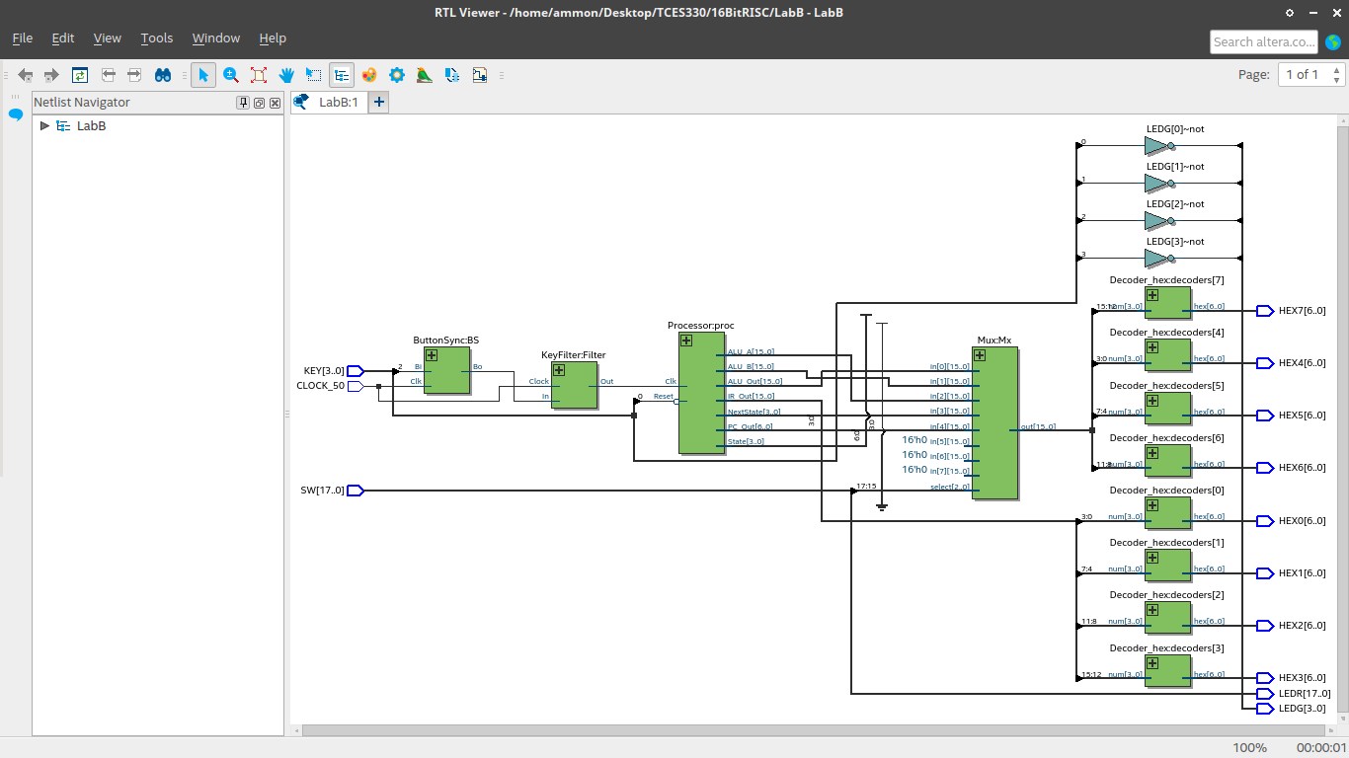

Figure 3: Top level RTL generation for the processor

Simulations:

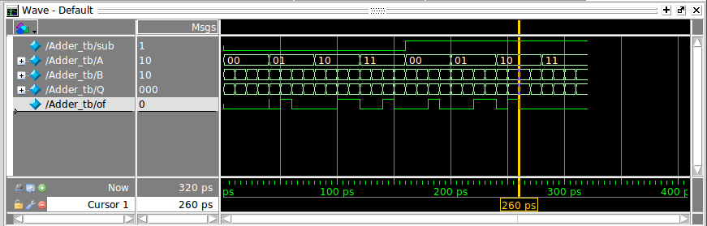

Figure 4: Adder timing diagram we created to check for signed and unsigned bit overflow and underflow (Allen n.d.).

Timing diagrams show the relationship between transitions, where some show transitions on different signals or the same signal (White 2011, 46). For testing for signed and unsigned bit overflow and underflow we reduced the bit length to two. The ALU does not know about signed or unsigned numbers, it simply does the binary arithmetic we ask it to. This timing diagram show results that we expect of the adder.

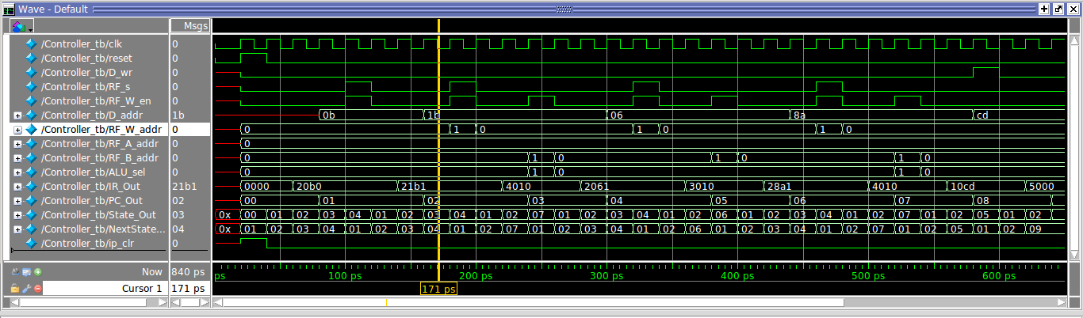

Figure 5: Timing diagram for the Controller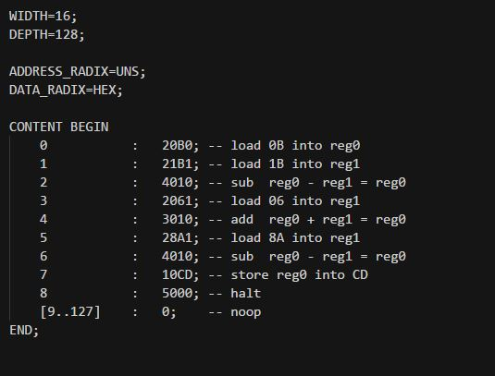

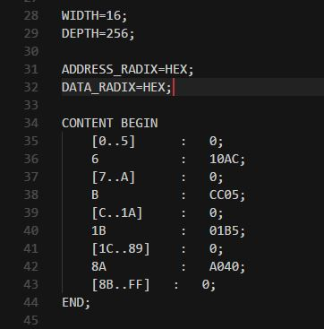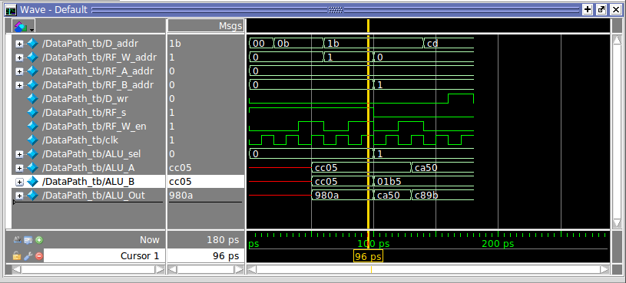Above is the timing diagram of the controller module, showing each instruction being loaded an executed as instructed. By looking at IR_Out we see that the controller performs as we expected, as can be seen from the mif file. At first when testing the controller, we ran into issues of the program counter being delayed one extra clock cycle. This was fixed by changing our finite state machine operated in the control unit module.

Figure : Instructions from mif file

Figure : datapath timing diagram

The datapath worked as expected also, developing this testbench required considerably unorthodox strategies. Looking at memory data within modelsim showed initially that we were storing each element off by one. This was fixed by simplifying the ALU and changing how we called modules inside of the datapath along with other miscellaneous changes.

The control unit was tested by simply traveling between states.